Spiritual Formation Blog
Spiritual Formation
To understand the spiritual realm, I need to have strong faith in the gospel and the entire word of God. Having strong faith and trust in the gospel is the basic understanding of God and his beloved son Jesus Christ. God speaks to people through the word. For every person who wants to know more about God, reading the bible is mandatory. Understanding the relationship between God the Father, the Son and the Holy Spirit will build more on the Christianity foundation. Christianity involves a deep spiritual connection between man and God, and Christians believe in the Son Jesus Christ. Spiritual formations are how a Christian can lay a foundation of being holier and worshiping God appropriately.
Spiritual Formation Concepts that I Need to Incorporate in my Walk of Faith
Spiritual formation is a continuous process in a Christian’s life until the time God will glorify us. Spiritual formation is one way for Christians to grow and form themselves in the most appropriate holy way. Spiritual formation refers to all that God puts in place to ensure that we look like Him and we do the things that will make us be in the line of pursuing the spiritual Goals. Worship and spiritual formation, as a Christian, I have to incorporate worshiping as my spiritual formation tool. Worshipping of the true God is a spiritual formational way to every Christian. God requires all human beings to worship him only, and failure diverts our formation from the right course. Understanding that worshiping one and true God is mandatory to spiritual formation, then we as Christians will be living a life heading nowhere but in our minds believe that we live as per God’s expectations. As Jesus puts it to the woman at the well, God seeks those who worship him in “spirit and truth” (John 4:23-24). Worshipping is what keeps us as Christians connected to God direct.

The second formation I will incorporate in my life as a Christian is spiritual formation and discipleship. In the life of a Christian, discipleship entails being a follower of Christ. This can as well be referred to as imitating Christ in our daily activities. For instance, a deeply rooted Christian will find a Christian group and mentor them to become Disciples of Christ. This is done in observance of the gospel and the word of God in general. Discipleship is a way of Christian formation that encourages other Christians to emulate the good characters of the mentor. God uses the discipleship programs to bring us to spiritual maturity.
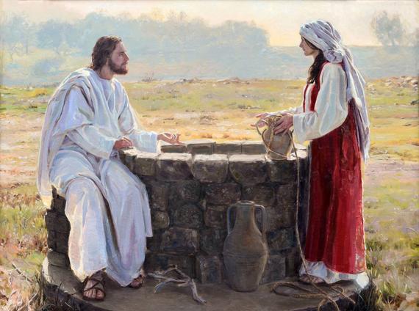
Jesus and the Samaritan woman at the well
Plan of Action for addressing Worship and Discipleship in My Christian Life
The best plan to be used to implement the spiritual formation of a Christian is through worship groups. The worship groups will ensure that the art of worshiping is instilled in our lives as Christians, and we worship only one God in truth and spirit. Worship is a divine connection between man and God in the spiritual realm. As a Christian, I have to ensure that I practice the right ways of worshiping since I want to follow the path of Jesus Christ. In the gospel books of the Bible, Jesus worships God the Father severally. This implies that as Christians, I should worship in truth and spirit the way Jesus did. Emulating what the son did before God raised and glorified him is enough to impact the best worshiping ideas that I will apply in our daily lives. The confidence that Christians have in Jesus should be paramount in ensuring I live like Jesus Christ.
Discipleship to Christians will be significant to all who want to live a holy life. The procedure is to copy what the Son Jesus Christ did strictly. All His life, Jesus remained holy and observed the available commandments that shape Christianity. I will enroll in discipleship programs and ensure I have a holy mentor and I also emulate prosperous Christians. Some of the daily activities of Christians such as visiting the sick, praying together, nurturing the fruits of the spirit make us become genuine disciples of Jesus in spirit and in actions. Even though some people try to bring down others who choose to dedicate their lives and time to serving God, I will stand firm by the word just as the Disciples did, even though some of them died painful deaths when they were defending the word of God.
My advice to Antony who wants to join a seminary, to become a priest
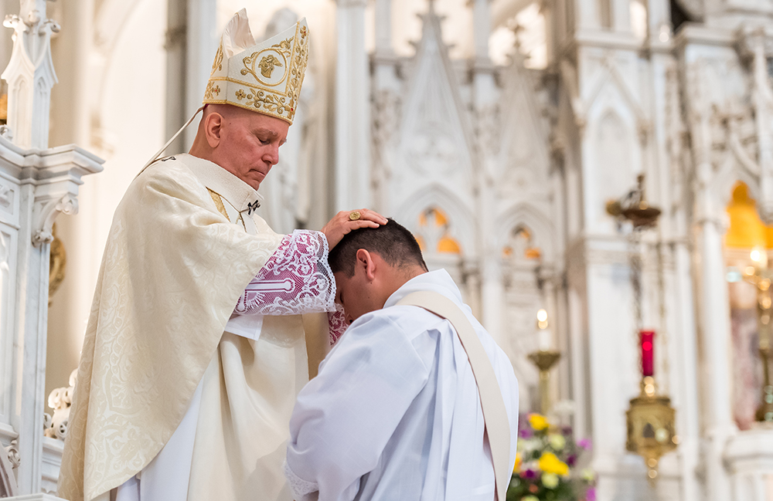
Antony is a young man devoted to serving Christ and he has decided to become a priest. Therefore, I have to advise him to prepare for the journey ahead. Since he has decided to join a seminary, Antony should accept Jesus as his savior and that Christ is the son of God and He resurrected from the dead. Accepting Christ as a personal savior will make Antony accept and believe in Jesus and his teachings. Christian values such as the fruits of the spirit should be practiced daily to ensure that he incorporates them into his system and keeps on growing spiritually. To be a priest, you have to be an example to others, and then Antony has to emulate the doctrines of a disciple so that he becomes a disciple of Christ Jesus. Formation of a real Christian entails putting effort and strict observance of Jesus’ teachings outlined in the gospel books of the Bible and the New Testament. When he graduates from the seminary, he should come out as a true disciple of Jesus Christ who worships in spirit and truth to be a spiritual leader. Being a priest, he will be the spiritual leader, and he will be the one to win souls for Christ. This is a task that will involve convincing non-believers to believe. Antony should prepare for a hard task ahead, and he should arm himself with the word of God to convince and counter the antagonist of the word.
In conclusion, becoming spiritual and holy before God is something every Christian will have to sacrifice to attain. Being a disciple and worshiping God in spirit and truth is a basic requirement for living a faithful and holy life. Living life like Christ Jesus is the only best way to live as a Christian. Therefore every Christian should lay down foundations that will lead to attaining spiritual goals.

